LAPP strengthens global and regional management
Matthias Lapp focuses on role as CEO, Michael Seddig heads EMEA region
Stuttgart, January 16, 2025 – Going forward, Matthias Lapp will devote his full attention to his duties as CEO of LAPP Group: He will hand over his role as CEO of the important EMEA region (Europe, Middle East, Africa) to Michael Seddig with effect from April 1, 2025. Seddig has been responsible for purchasing, production and logistics in the region as Chief Operating Officer EMEA at LAPP since July 2023.
“With this key personnel decision, we are strategically strengthening our global and regional management structure in order to align our organization even more quickly and precisely with the needs of our customers in the future. It was clear to me right from the start of the generational change, that I would ultimately like to focus on the global CEO position. I wanted to fill the regional management position internally. We have now found the right person for this role from within our own ranks”, says Matthias Lapp.

The family initiated the handover to the third generation in 2022, when Andreas and Siegbert Lapp withdrew from the LAPP Group's operational business. Matthias Lapp took over as CEO from Andreas Lapp after twelve years with the company. Katharina Lapp succeeded Siegbert Lapp on the LAPP Group's Supervisory Board. Since then, Matthias Lapp has fulfilled his role as CEO of the Group in addition to his EMEA role. During this time, he successfully steered the company through economic and geopolitical challenges.

Strong implementation, experienced, customer-oriented
From April 2025, Michael Seddig will be responsible for the family-owned company's largest sales region as CEO EMEA. Over the past one and a half years, as COO EMEA, he has driven forward the alignment of the supply chain with the customer, a wide range of process improvements and massive expansions of production capacities. He continues in this role. Before joining LAPP, Michael Seddig held global, customer-facing management positions at LEONI, a supplier of cable solutions and wiring systems for the automotive industry.
Matthias Lapp: “Translating the needs of our customers into our organization: Michael Seddig embodies this with full conviction. This holistic customer focus combined with his extensive experience as a supply chain manager are a real added value for LAPP. I am very pleased that he will be leading the EMEA region in the future - pragmatic, strong in implementation, human and customer-oriented.”

Michael Seddig: “I am taking on this task with great anticipation. LAPP is a special company with a fantastic team and a strong culture. Together, we will continue to lead the EMEA region successfully into the future. Despite the current economic challenges in our core Central European markets, we continue to drive forward our strategic transformation towards becoming a solution provider. With a targeted focus on our growth markets in the Middle East and Africa, as well as future industries such as renewable energies, intralogistics, and e-mobility.”
Change in the Supervisory Board of the European parent company
In parallel, Andreas Lapp is stepping down from the Supervisory Board of the European parent company U.I. Lapp GmbH. He will be succeeded by his nephew Matthias Lapp, who will join the Supervisory Board after stepping down from the EMEA management. As the parent company of the LAPP Group, U.I. Lapp GmbH is named after the company's founder Ursula Ida Lapp.

Andreas Lapp: “One thing is clear: LAPP is and will remain a genuine family business. Family members will continue to guide the fortunes of the LAPP Group in the future.” The change in the Supervisory Board of U.I. Lapp GmbH will not result in any changes to the Supervisory Board of the global Lapp Holding SE. This consists of the Chairman of the Supervisory Board Dr. Hans Schumacher, as well as Peter Schmid and Katharina Lapp.

***
Images
For this press release, you will be provided with digital images in printable resolution. The photos may be used free of charge. No graphical editing is permitted, except for cropping the main motif.
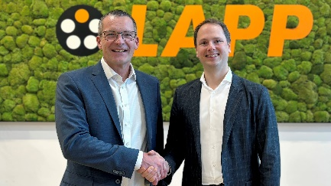 | Michael Seddig & Matthias Lapp  Matthias Lapp (right) hands over his role as CEO EMEA to Michael Seddig.  Photo: LAPP  You can download the image here.
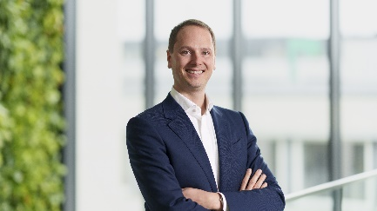 | Matthias Lapp  Matthias Lapp will in future be focusing fully on his role as CEO of the LAPP Group.  Photo: LAPP  You can download the image here.
Pressekontakt:

LAPP Austria GmbH  Bremenstraße 8  A – 4030 Linz  www.lappaustria.at | Claudia Stieglbauer  Tel. +43 (0) 732 781272 201  claudia.stieglbauer@lapp.com

About LAPP
Headquartered in Stuttgart, Germany, LAPP is a leading supplier of integrated solutions and branded products in the field of cable and connection technology. The company's portfolio includes standard and highly flexible cables, industrial connectors and screw technology, customised system solutions, automation technology and robotics solutions for the intelligent factory of the future, as well as technical accessories. LAPP’s core market is in the industrial machinery and plant engineering sector.

The company was founded in 1959 and is still entirely family-owned today. According to preliminary figures, it generated a consolidated sales of slightly more than 1.8 billion euros in the 2023/24 financial year. LAPP employs around 5,800 people worldwide, manufactures at 21 international locations and is active in a total of over 80 countries worldwide.
Folgen Sie LAPP:


